# AGI Software Release Note

**Release No. :** AGI v2.2.1 **Release Date : 27/3**/2020 **Release Description :**

1. User will be able to Enable / Disable Input parameters using Master Data Maintenance screens. Below are some of the actions and validations to be considered while enable/disable input parameter. (SI No. 2)

* If any parameters are disabled, system will raise warning if these parameters are used in the calculations in derived parameters. User can can choose to go ahead with disable. After disable it will be removed from all AGI screens, search, input module, output module etc. (SI No. 3)
* If any new parameter is added, it will appear in all AGI screens i.e. Search, input module and output module etc. No calculations will be impacted due to adding of any new parameters. (SI No. 4)

1. Defining Relationship b/n machine model and input parameters dynamically. Eg. Machine model and Max Dia, Min Dia etc. (SI No. 6)
2. Added 'Stock on Face (mm) ' column in Operation Parameter for Face Grinding.(SI No. 8) Column empty – No textbox visible but after some more testing it appeared , is it a bug?

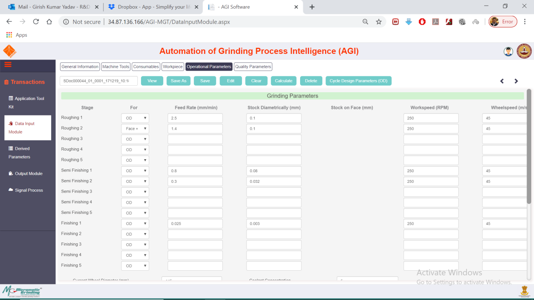

1. In front of all the Feed Rates, Drop down can be provided for OD, Face, Radius, OD+Face. (SI No. 16)
2. Once Drop down for OD, Face, etc appears align the heading properly. In this case ‘ Stage’. (SL No. 110). Please shift stage to left, to align properly
3. In Statistics, instead of giving TotalMRR for 15 parameters(like Roughing 1, Roughing 2….., Semifinishing1……., Finishing1……) sum up that 15 values and give only one TotalMRR. Same for all derived parameters. (SI No. 12)
4. ‘Diameter after’ to be removed in the application toolkit display. (SI No.49)
5. Following access levels to be given according to Username and Password. 1. Admin2. Master User 3. User 1 4. User 2 (SI No. 55) Not assigned any pages error. During assigning no user ID is shown

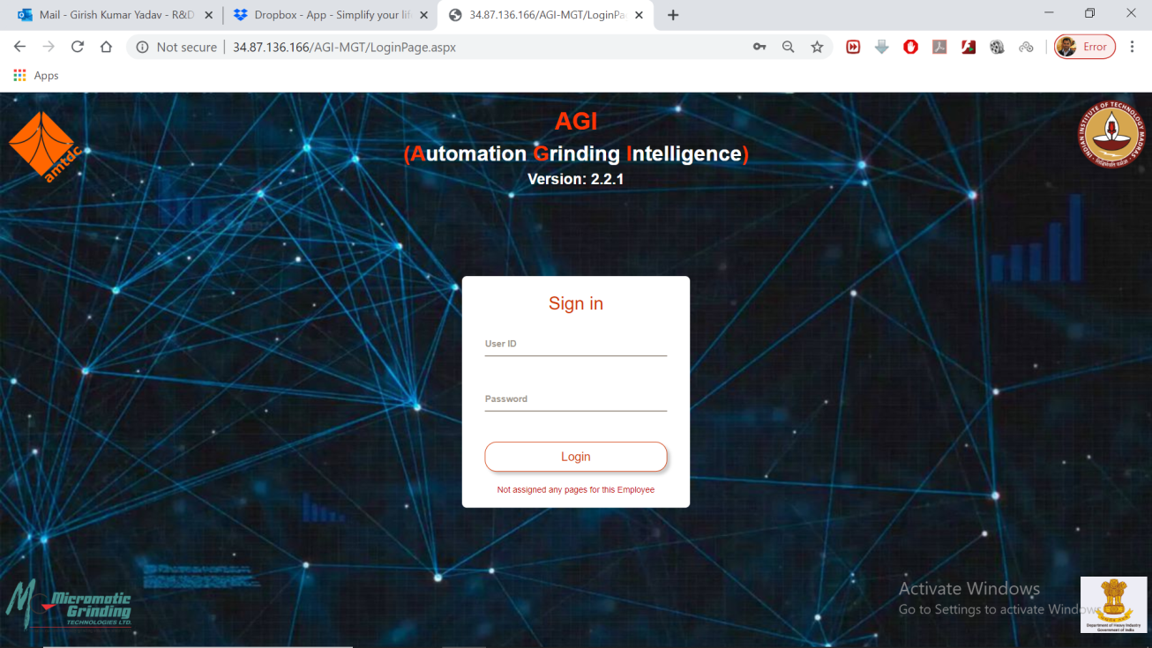

1. System Document text is not required on the top , for our reference it has to go to Footer. (SI No. 57)
2. Unit of hardness to appear and paranthesis for units. (SI No. 60)
3. First image will take the full length, total 3 images to appear. (SI No. 61, 74)
4. Change table heading from ‘Output’ to ‘Quality Parameters’. (SL No. 64, 76)
5. Quality Parameter to appear side by side to reduce number of pages.(SL No. 65, 77)
6. Total Cycle time graph to be changed to Pie chart. (SL No. 67)
7. Total Cycle time will have 2 tables. One for Calculated Cycle Time . One for Actual Cycle Time. (SL No. 78)
8. ‘Calculated Parameter’ table and graph to be shifted at the end of full report. -- shifted after 'Quality Parameter Details'. (SL No. 75)
9. Add label ‘ Calculated Time’. (SL No. 80)
10. Labels in graph are not coming completely, this may reflect in Output reports also , hence this should be fixed for ALL graphs. Units of time are sec, it is showing cu. mm/s. (SL No. 103)
11. Roughing MRR ,etc graph not required -- removed from default report (SI No. 63)
12. Loading / Unloading Time (sec) text to be changed to Loading/ Unloading (sec)in Derived Parameter. (SL No. 118)
13. Suggestion of time appears in drop down. Not required in Derived Parameter. (SL No. 119)
14. Landing Page for AGI Software. (SL No. 124)
15. Everywhere search option to have parameter based search and Tab wise bifurcation. (SL No. 120) – Text is very large, please make it consistent with others

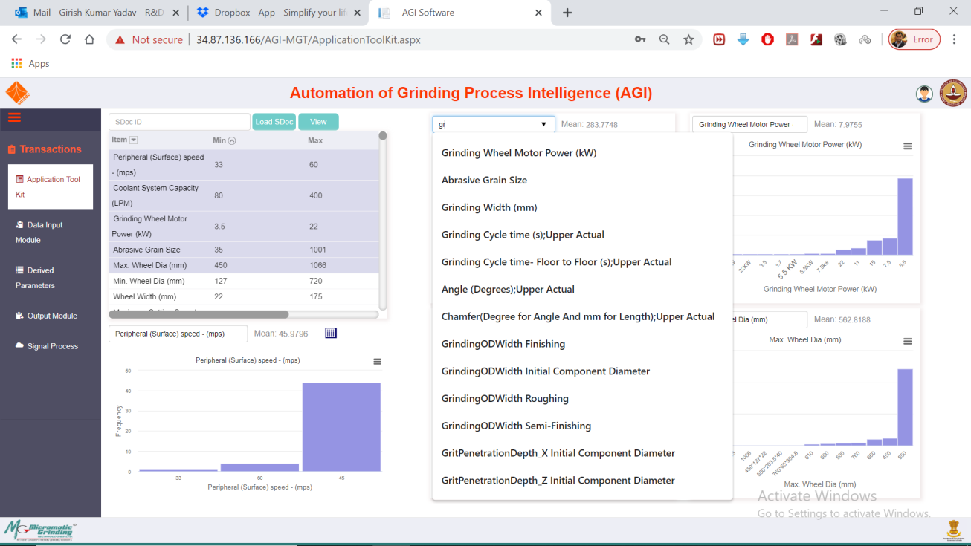

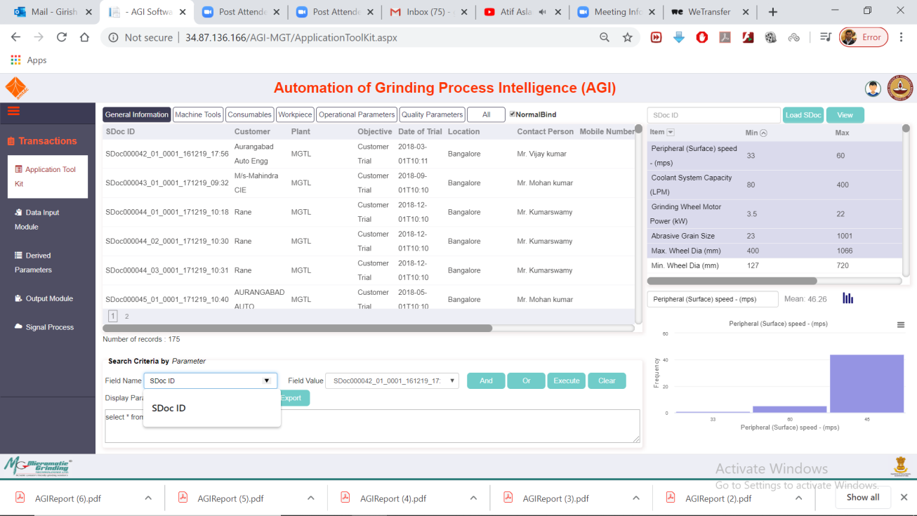

In search field it only shows SDoc but when we start typing new parameters come. Atleast initially it should show all parameters when this is pressed

1. Peripheral Speed, Coolant Capacity, Grinding Wheel Motor Power is not in ascending order. (SL No. 90)
2. Displayed only top 10 values in ATK graphs. What does it mean? What point number in tracking sheet?
3. Added 'Input Component Dia-OD (mm)' parameter in workpiece , it was always available – Input component Face- (OD) was not available Please clarify
4. Introduced 'Chip width / thickness ratio' , 'Wheel Tilt Angles' , 'Equivalent Dia Face', ' Cutting Edge Density' in Derived Parameter.
5. Introduced Derived Parameters in Output Module. – Some derived calculations are coming in scientific format. Please correct it 1.57648820997779E. Please round up these values till 5th decimal place

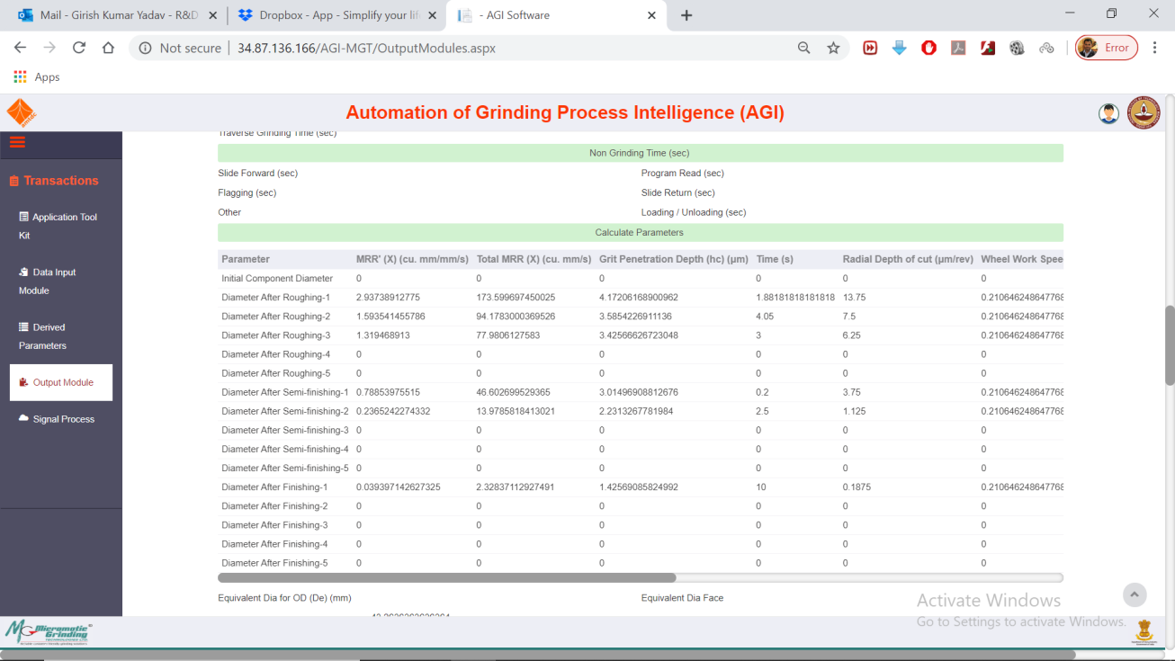

1. Resizable image. – Not working – Can’t drag, can’t resize
2. Calculated and operational parameters has to be modified for including face grinding. (SI No. 51)- Cycle Time Calculation
3. Include unit for Quality Parameter. (SL No. 112)

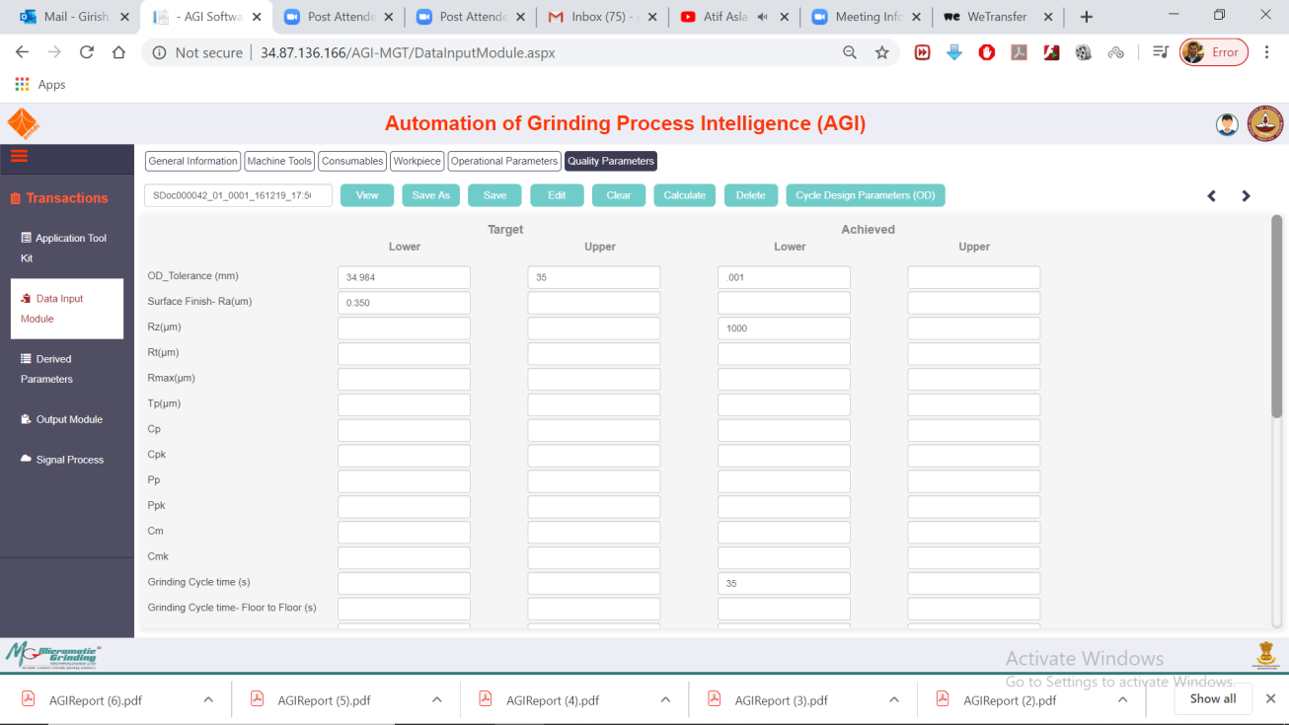

Again lower Target textbox are appearing for some parameters. This point was already sorted out in previous versions but again it appeared.

1. Current signal processing application is built on mat lab using windows odbc Administrator for setting up connectivity with sql DB. Instead connectivity can be configured thru web.config and application can read this file for DB connectivity. (SL No. 41)

Other Points –

1. What are the limitation of number of images that can be saved?
2. Dresser Speed unit still missing in
3. Dresser feed rate has unit in improper format
4. Crush Ratio calculation open by adding the Dresser Dia separately in the page
5. Spelling of Custom report wrong in output module
6. Make Export as ‘Excel’ in output module or can be as in Export optional 1. Excel 2. Pdf (In pdf 2 Options)
7. Calculations in derived parameters are coming wrong.
8. Report names should be saved by System Document _Default/Custom report. Right now everything is saved as AGI Report.
9. Grinding Wheel Make in Consumables was needed to be with Drop Down list
10. Coolant Concentration % Not shown
11. No limit Values are set yet; user can put any value as shown below

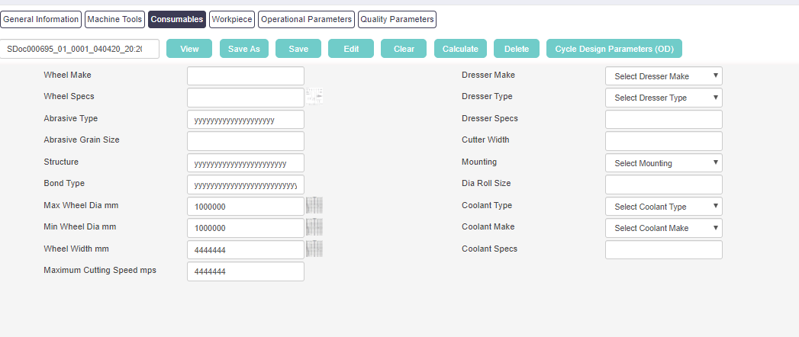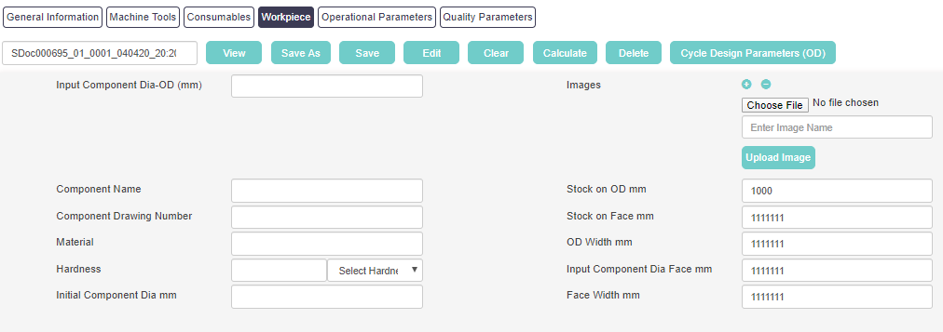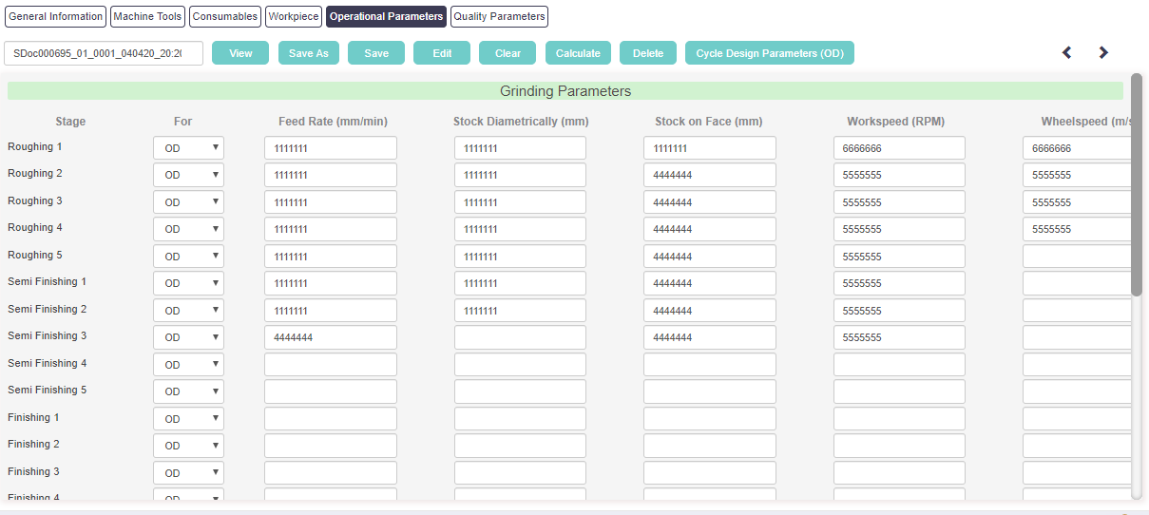

Note: Simply copy all files of AGI Software application and paste into AGI folder (C -> inetpub -> wwwroot -> AGI ) except UploadImage and Web.xml files.

# List of Files Released

## DB Script. - AGI Project Docs\AGISoftwareApplication\AGISoftwareV2.2.1\DataBase\Script_V2.2.1

* Web Application files. -AGI Project Docs\AGISoftwareApplication\AGISoftwareV2.2.1\App\PublishedCode
* FolderStructure